**Phase 4: Process Automation (Admin)**

**Validation Rules:**

**Reason:** Ensure data integrity and enforce business rules.

|  |  |  |  |
| --- | --- | --- | --- |
| Object | Rule Name | Formula | Error Massage |
| Opportunity | Amount_Must_Be_Positive | ISBLANK(Amount) || Amount <= 0 | Amount must be greater than 0. |
| Opportunity | Close_Date_Cannot_Be_Past | CloseDate < TODAY() | Close Date must be today or a future date. |
| Order | Discount_Cannot_Exceed_Limit | AND( $RecordType.DeveloperName = "Bulk_Order", Discount__c > 50 ) | Discount cannot exceed 50% for Bulk Orders. Please get manager approval. |
| Order | Prevent_Zero_Total | ISBLANK(Total_Amount__c) || Total_Amount__c <= 0 | Amount must be greater than 0. |
| Inventory | ReservedQty_Cannot_Exceed_OnHandQty | ReservedQty__c > OnHandQty__c | Reserved Quantity cannot exceed On-Hand Quantity. |
| Order Item | Quantity_Must_Be_Positive | Quantity__c <= 0 | Quantity must be greater than 0. |

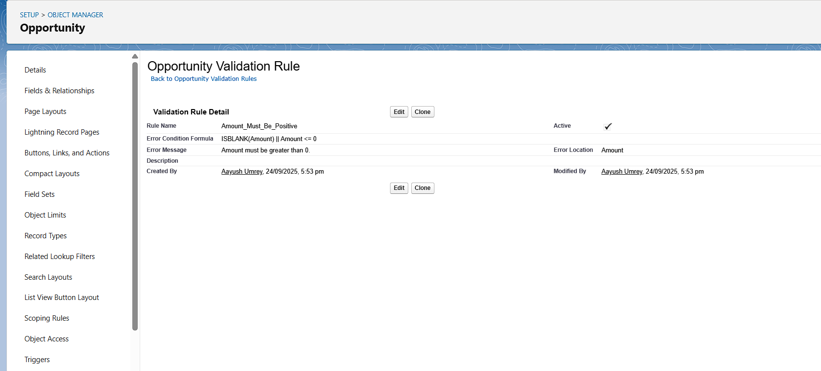

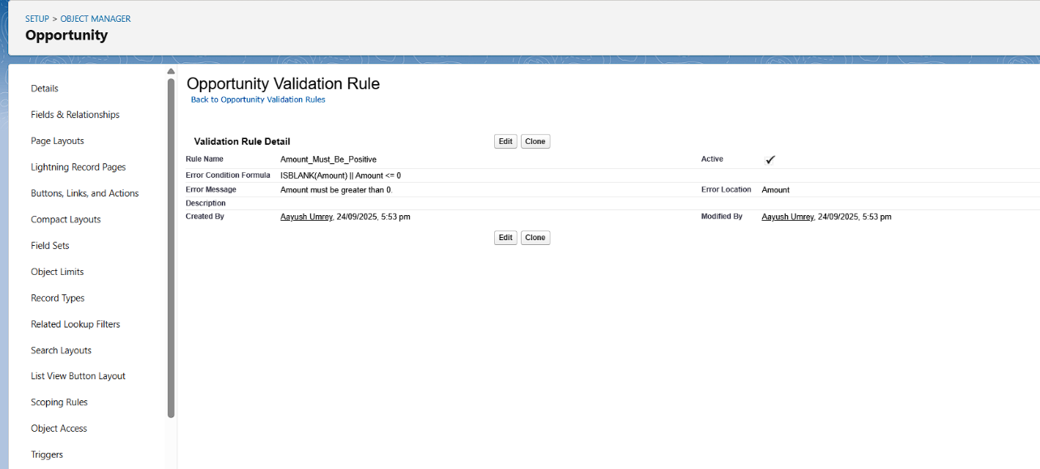

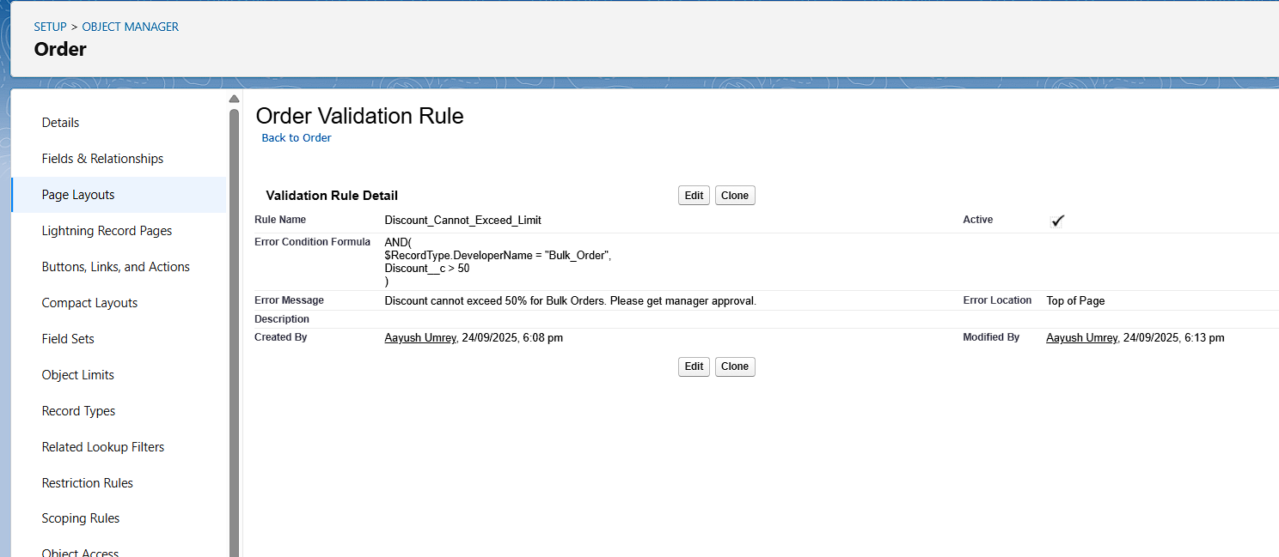

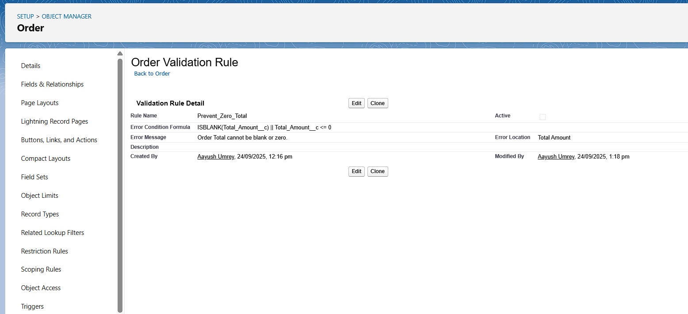

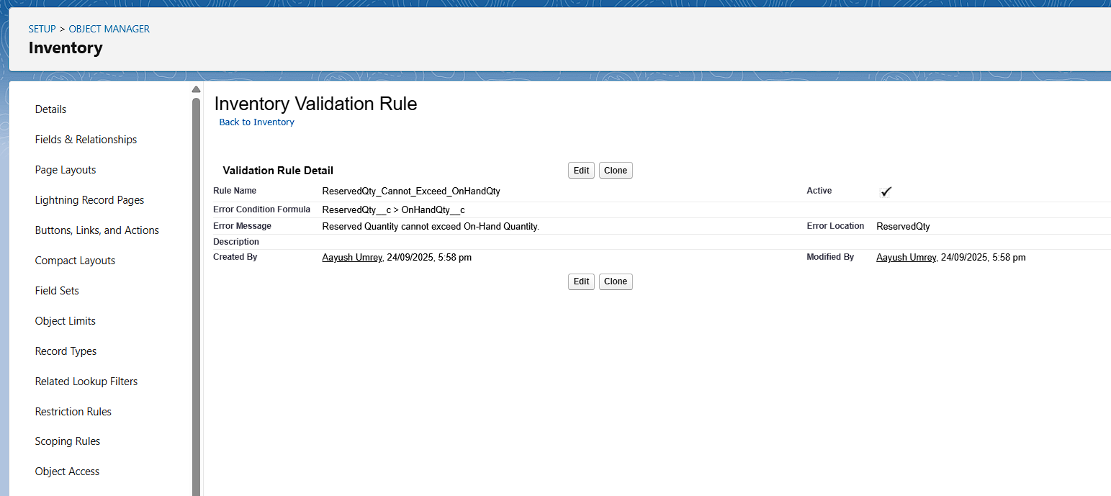

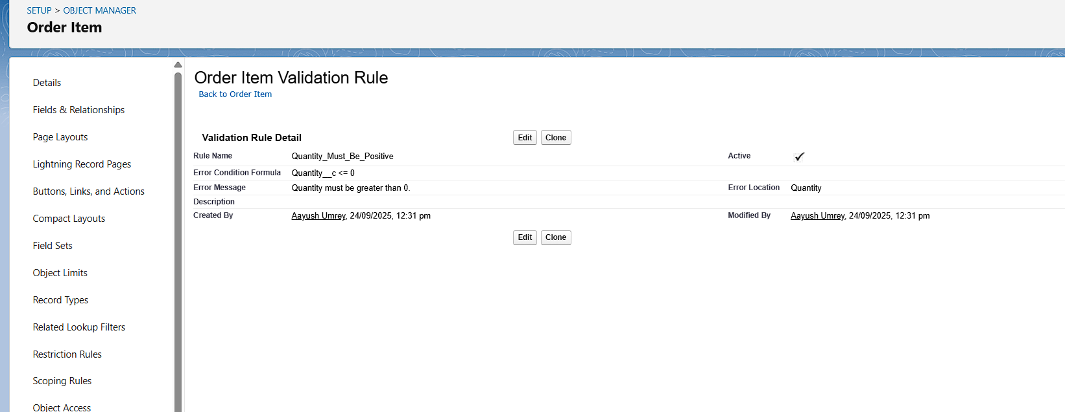

**Workflow Rules:**

**Reason:** Automate simple actions (Task creation, Email alerts, Field updates).

Object: Opportunity  
- Criteria: Opportunity:Stage = Closed Lost  
- Immediate Actions:  
• Create Task → Assigned to Sales Manager,

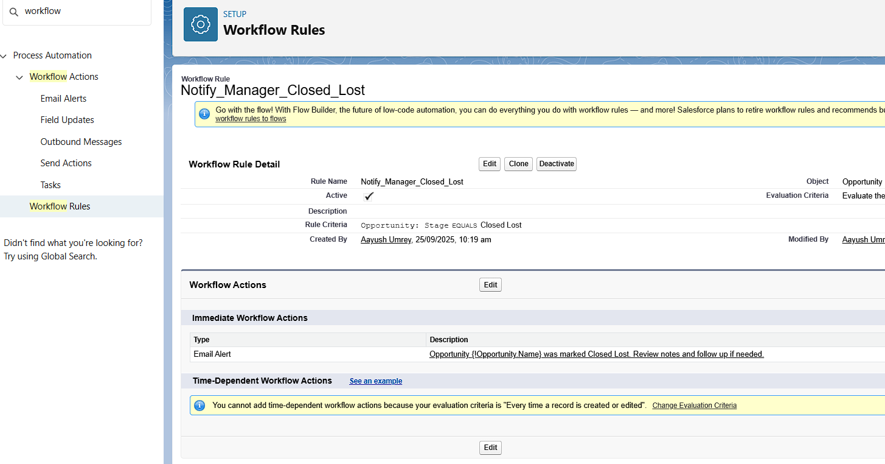

**Process Builder:**

**Reason:** Automate multi-step processes with more flexibility than Workflow Rules.

Example: Stage_Closed_Won

Trigger: Created or Edited

Immediate Actions:

Create_Order_From_Closed_Won_Opp

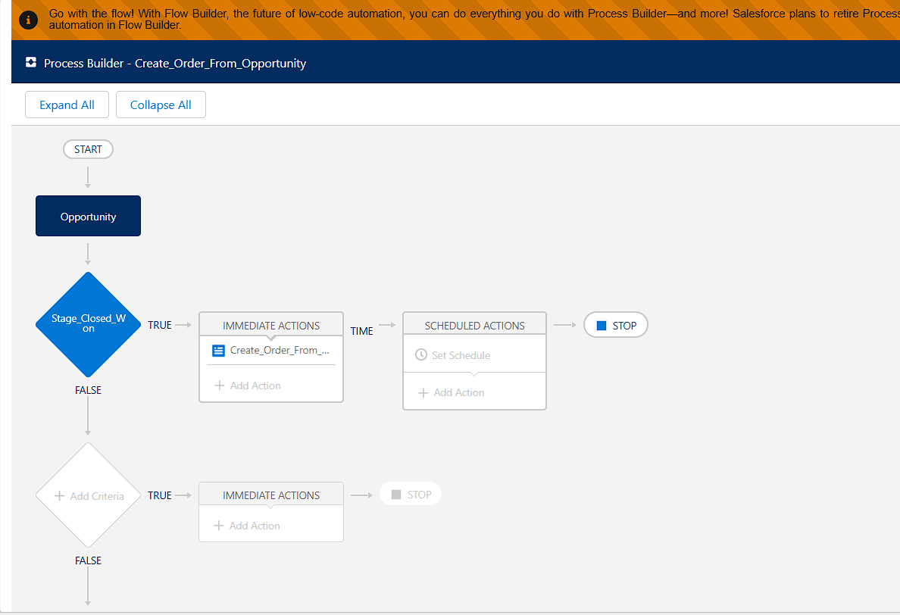

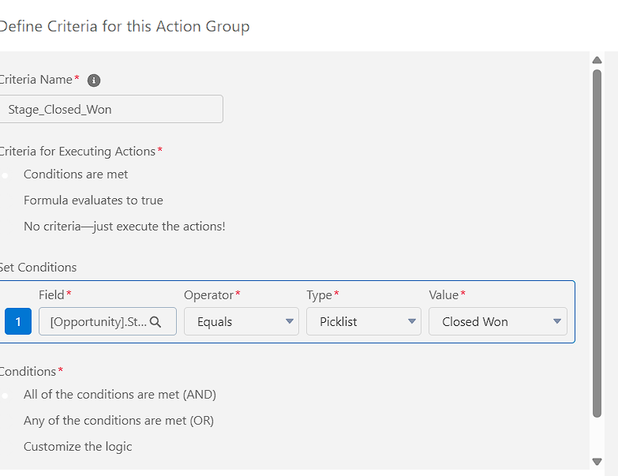

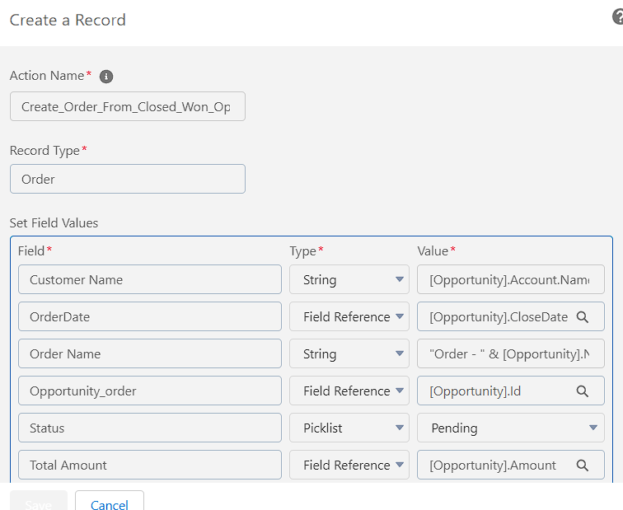

Example: Item_Delivered

Trigger: Created or Edited

Immediate Actions:

Update_Order_Status

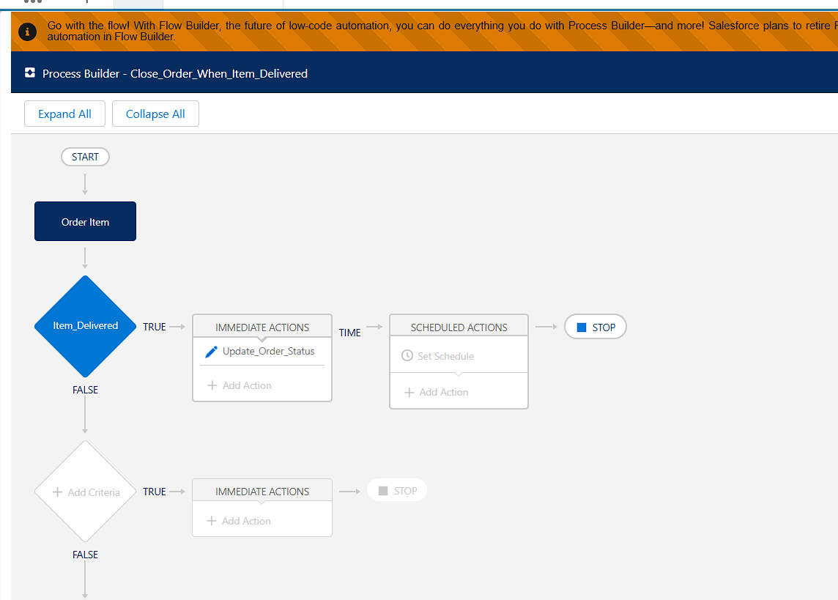

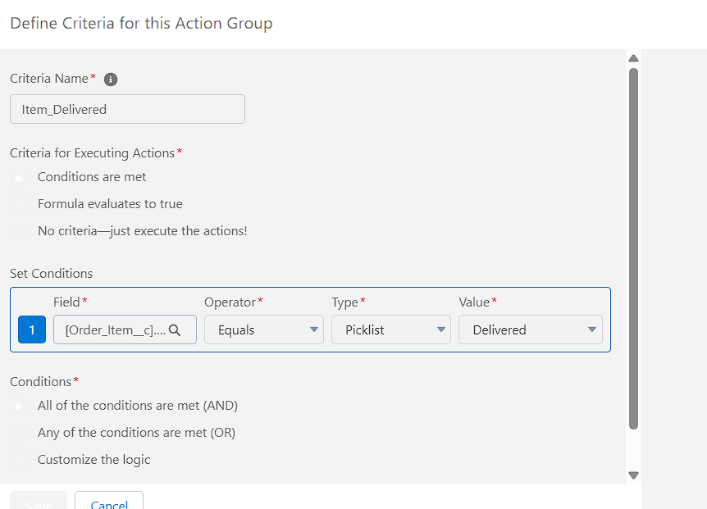

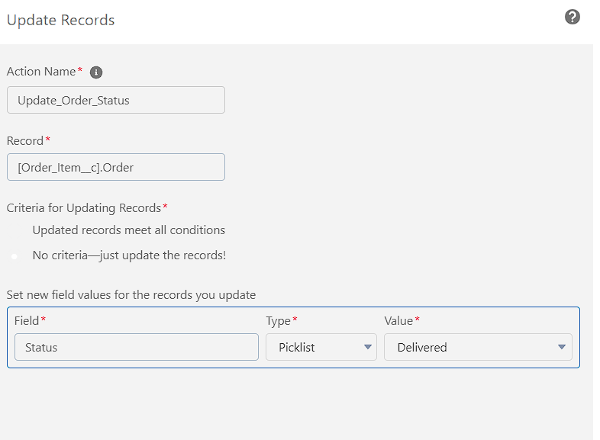

**Approval Process:**

**Reason:** Automate record approvals for compliance or business rules.

Example: - Object: Order

- Entry Criteria: Order: Status Equals Pending  
- Approver: Sales Manager

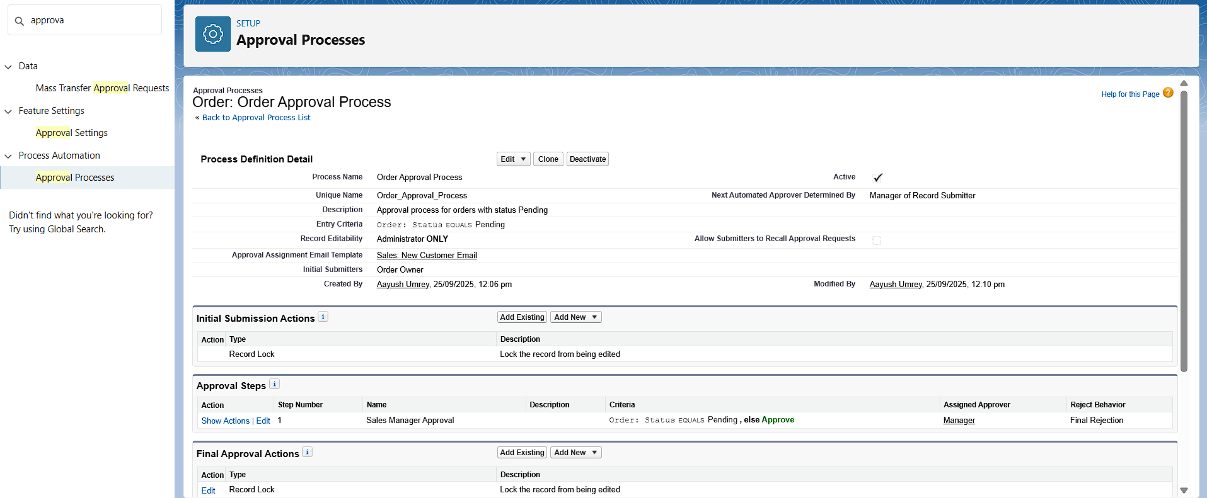

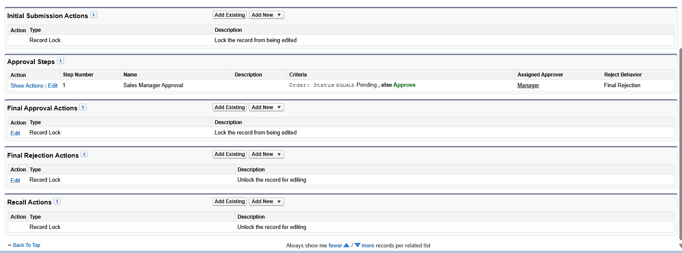

**Flow Builder (Screen, Record-Triggered, Scheduled, Auto-launched)**

**Reason:** Advanced automation to create, update, and interact with records.

Example: Record-Triggered Flow – Order Item  
- Trigger: A record is created or updated  
- Condition: DeliveryStatus = Deliverd  
- After Save Actions:  
 • Update Record → Update Parent Order Status

Then

• Send Email Alert

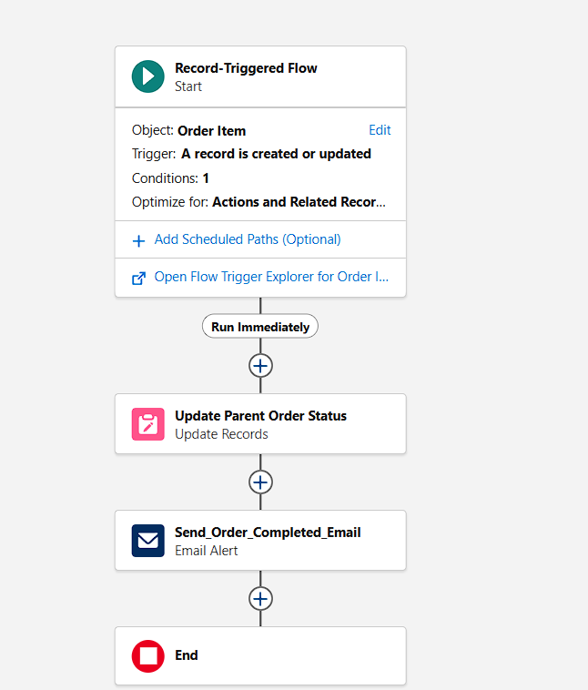

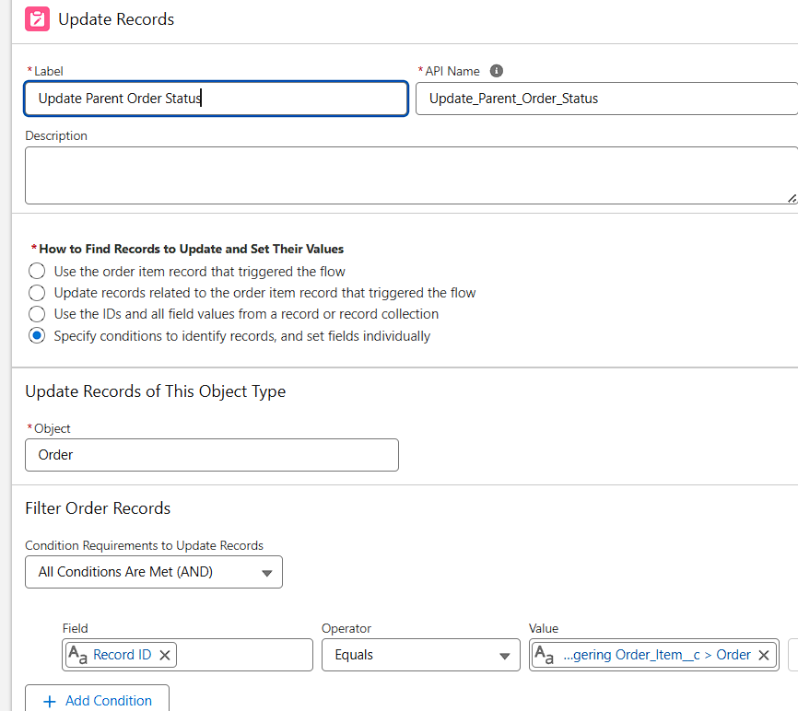

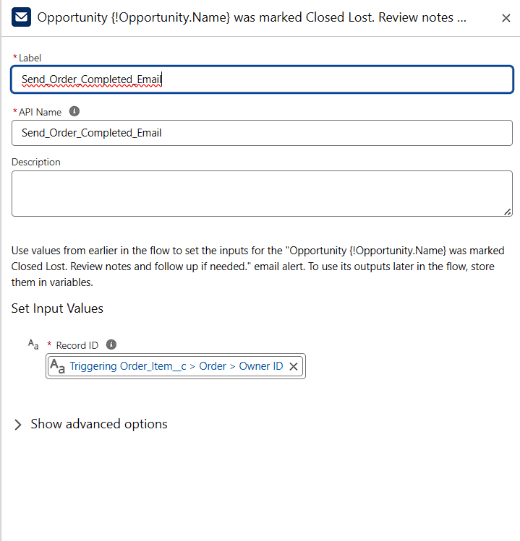

**Email Alerts:**

**Reason**: Notify users automatically via email.  
- **Template**: Low_Stock_Notification

- **Recipients**: Manager (User)  
- **Usage**: Attached to Workflow Rule, Process Builder, or Flow

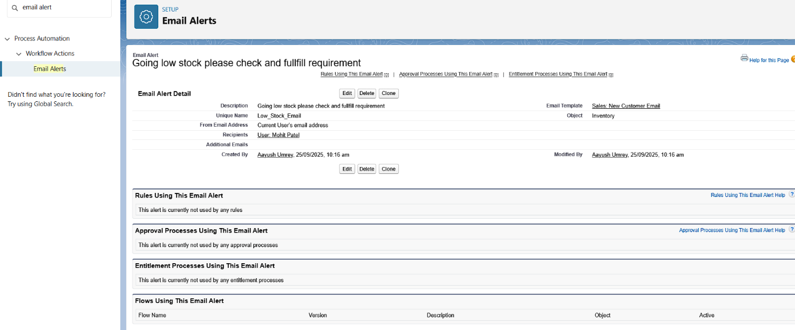

**Field Updates:**

**Reason:** Automatically update field values.

**Field Update created under WorkFlow and can also be created under flow builder for fast automation.**

**Name: Update_Status_To_Pending**

**Field to update: Order: Status**

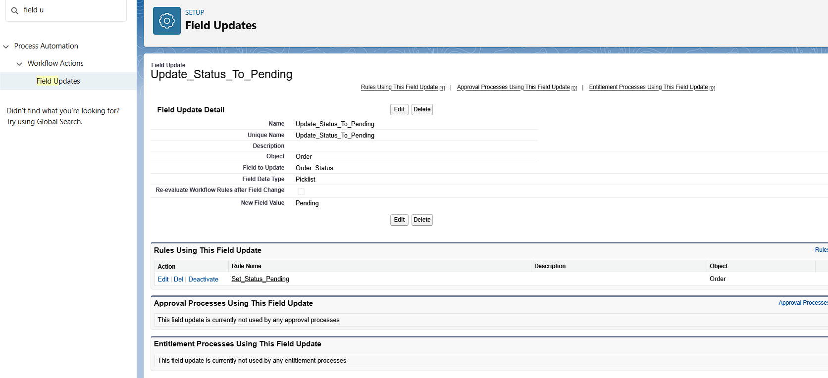

Tasks:

**Reason**: Automatically assign follow-up tasks.  
- Covered in Workflow, Process Builder, and Flow Builder examples.

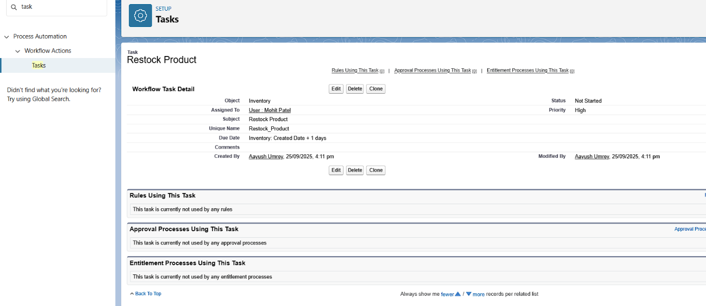

**Custom Notifications:**

**Reason:** Notify users in-app and via mobile for important events.  
- Example: Notify Sales Manager when a Bulk order is submitted.  
- Steps:  
 • Setup → Custom Notifications → New → Name: Bulk Order Approval Notification

